

**Applied Physics for**

**Scientists and**

**Engineers**

**Lab Report: Determine the Given High Resistance by Leakage method**

**Submitted to**

Sir. Haseen Ullah Jan

**Submitted by**

Muhammad Sadeeq ETEA No. 75025

Computer Systems Engineering Sec C

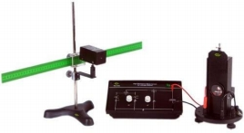

**Leakage Method:**

Leakage method is one of the most effective and accurate methods used to measure the value of very high resistances.

**Principle Used:**

In leakage method, main concept used to calculate the value of resistance is the charging and discharging of a capacitor. A ballistic galvanometer is used to measure the amount of charge that the capacitor/condenser discharges.



**Experiment:**

**Apparatus Used:**

list of items required to measure resistance by leakage method:

● Ballistic galvanometer

● Power supply / accumulator

● Capacitor

● Resistor whose value is to be measured)

● Few connecting wires

● Tapping key & morse key

● Lamp and scale arrangement

● Stop watch

**Procedure:**

Following procedure is followed:

1. Ballistic galvanometer is ﬁrst calibrated to its zero point to remove any error.
2. Dampening key is drawn out so that current can pass through the galvanometer in order to take readings.

1

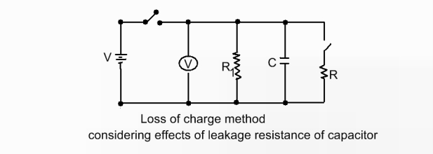

1. Press key K1 so that the current is charging the capacitor.
2. Now key K1 is released and K2 is engaged.
3. Charge on the capacitor will leake to Ballistic galvanometer and give an instant reading.
4. The deﬂection θ and θ2 will be ﬁrst and highest deﬂection of the pointer i.e. light spot.
5. The dampening key is again inserted to reset the apparatus.
6. Capacitor is charged by putting key k1 in its place.
7. Releasing K1 and putting K3 back in its place for a known time T.
8. Time is noted and K3 is released,
9. K2 is pressed and reading on galvanometer is taken again.
10. Reading is noted as θt.
11. Θt should be less than θ0 because some charge is already leaked by pressing K3. Resistance is measured by K2 again by formula

R=

*t*

*cln*

~~θ0~~

θ*t*

Where c is the capacitance of the capacitor.



**Readings:**

|  |  |  |  |  |
| --- | --- | --- | --- | --- |
| S. No. | θ0 | θt | t | R= *t*  θ0  *cln*  θ*t* |
| 1 | 65 | 39 | 6 | R=11.76 MΩ |
| 2 | 73 | 52 | 4 | R=11.76 MΩ |
| 3 | 68 | 49 | 3.8 | R=11.51 MΩ |
| 4 | 74 | 49 | 4 | R=9.76 MΩ |
| 5 | 75 | 43 | 5 | R=9.26 MΩ |
| 6 | 70 | 40 | 6 | R=10.73 MΩ |



**Precautions:**

Following precautions should be taken for this experiment:

1. Calibrate galvanometer very precisely.
2. Make connections tight and neat.
3. Capacitor should be charged fully.